**⇒ Mandatory Hands-On**

**Exercise 1: Mocking and Stubbing**

junitPractice/pom.xml

<project xmlns="http://maven.apache.org/POM/4.0.0" xmlns:xsi="http://www.w3.org/2001/XMLSchema-instance" xsi:schemaLocation="http://maven.apache.org/POM/4.0.0 http://maven.apache.org/xsd/maven-4.0.0.xsd">

<modelVersion>4.0.0</modelVersion>

<groupId>com.mycompany</groupId>

<artifactId>JUnitPractice</artifactId>

<version>0.0.1-SNAPSHOT</version>

<dependencies>

<dependency>

<groupId>junit</groupId>

<artifactId>junit</artifactId>

<version>4.13.2</version>

<scope>test</scope>

</dependency>

<dependency>

<groupId>org.mockito</groupId>

<artifactId>mockito-core</artifactId>

<version>5.3.1</version>

<scope>test</scope>

</dependency>

<dependency>

<groupId>org.junit.jupiter</groupId>

<artifactId>junit-jupiter</artifactId>

<version>5.9.3</version>

<scope>test</scope>

</dependency>

</dependencies>

</project>

ExternalApi.java

package com.mycompany.api;

public interface ExternalApi {

String getData();

}

MyService.java

package com.mycompany.service;

import com.mycompany.api.ExternalApi;

public class MyService {

private ExternalApi externalApi;

public MyService(ExternalApi externalApi) {

this.externalApi = externalApi;

}

public String fetchData() {

return externalApi.getData();

}

}

MyServiceTest.java

package com.mycompany.tests;

import static org.mockito.Mockito.*;

import static org.junit.jupiter.api.Assertions.*;

import org.junit.jupiter.api.Test;

import org.mockito.Mockito;

import com.mycompany.api.ExternalApi;

import com.mycompany.service.MyService;

public class MyServiceTest {

*@Test*

public void testExternalApi() {

// Arrange

ExternalApi mockApi = Mockito.*mock*(ExternalApi.class);

*when*(mockApi.getData()).thenReturn("Mock Data");

MyService service = new MyService(mockApi);

// Act

String result = service.fetchData();

// Assert

*assertEquals*("Mock Data", result);

}

}

Result

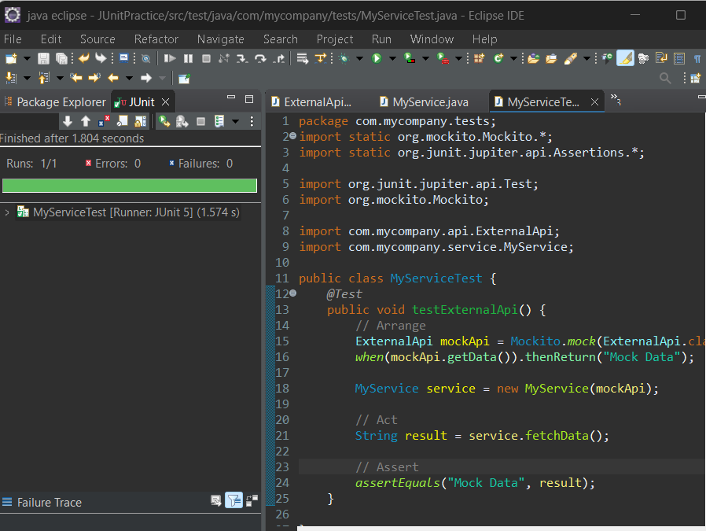

**Exercise 2: Verifying Interactions**

package com.mycompany.tests;

import static org.mockito.Mockito.*;

import static org.junit.jupiter.api.Assertions.*;

import org.junit.jupiter.api.Test;

import org.mockito.Mockito;

import com.mycompany.api.ExternalApi;

import com.mycompany.service.MyService;

public class MyServiceTest2 {

*@Test*

public void testVerifyInteraction() {

// Arrange: create mock

ExternalApi mockApi = Mockito.*mock*(ExternalApi.class);

MyService service = new MyService(mockApi);

// Act: call method

service.fetchData();

// Assert: verify the interaction

*verify*(mockApi).getData();

}

}

Result

